Energy and Efficiency Worksheet

For the following devices state what type of Energy is used from this list:
Chemical Kinetic Heat (thermal) Sound Electrical Light
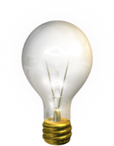
Light bulb: Input Energy ____________
Useful Energy ___________ Waste Energy _________
Electric Drill: Input Energy ___________
Useful Energy ___________
Waste Energy___________ & ___________
TV: Input Energy ____________
Useful Energy ___________ & ___________
Waste Energy ___________

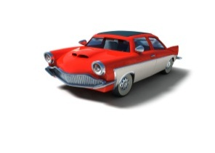
Car engine: Input Energy ____________
Useful Energy ___________
Waste Energy ___________ & ___________

Bunsen burner: Input Energy ___________
Useful Energy ___________
Waste Energy___________ & ___________
A Sankey diagram represents the energy transfer through a device.
Knowing that energy cannot be created or destroyed, energy input must equal the total energy output:
$$Total input energy=useful energy delivered+energy wasted$$
A Sankey diagram shows this:
Note: the width of the arrows demonstrates the amount of energy.
Wasted Energy
Useful
Energy

Device
Total Energy Input into device
Draw your own Sankey diagram for a 60W filament bulb given that:
Total input energy =60W
Useful (light) energy = 10W
Waste (heat) energy = 50W

Use the squares below as a guide for drawing your arrows.

The greater the percentage of energy that is transformed into useful energy in a device, the more efficient a device is:
$$Efficiency of Device= \frac{Useful energy transferrered by the device (output)}{Total energy supplied to the device (input)}$$
Efficiency can be written as either a number (which is never more than 1) or as a percentage (never more than 100%). Neither have units.
For example: A light bulb radiates 10W of energy as light, for every 60W of electrical energy we supply to it.
$$Efficiency of a lightbulb=\frac{10}{60} =0.17 (as a number)$$
$$Efficiency of a lightbulb=\frac{10}{60} x 100=17\% (as a percentage)$$
Now complete the table below, calculating the efficiency as both a number and a percentage:
 | Energy in | Energy out | Efficiency?
Electric Drill | 160W | Kinetic 90W  Sound 30W  Heat 40W
Hair drier | 180W | Heat 170W  Sound 10W
Mobile phone charger | 1W | 0.8W Electrical  0.2W Heat
Electric hob | 1500W | Heat 1300W  Light 150W  Sound 50W
Kettle | 2.5kW | Heat 2.2kW  Sound 0.3kW

Extension: Using the equation:$$Efficiency of Device= \frac{Useful energy transferrered by the device (output)}{Total energy supplied to the device (input)}$$
Fill in the gaps in the table below.

 | Energy in | Energy out | Efficiency?
Food mixer | 120W | Useful energy 80W  Waste energy 40W
TV | 180W | Useful Energy W  Waste energy 36W | 0.8  80%
Ipod | W | Useful Energy 0.6W  Waste energy 0.4W
Car engine | 30kW | Useful Energy kW  Waste energy kW | 0.45  45%
X box | 260W | Useful Energy W  Waste energy 70W
Mobile phone | W | Useful Energy 3.6W  Waste energy W | 0.45  45%

